Metropolitan State University, Saint Paul, Minnesota

ICS 140 Computational Thinking with Programming

Lab 6

**Common While Loop Patterns**

While loops can be used to execute a block of code as long as a specified condition is met. Some common uses of while loops is input validation.

In the example above, the score value is input on line 1 giving a base qualification for the while loop. If the input is valid (meaning it is within 0 to 100, the while condition is false and the indented code never runs. If however, the score is outside that range, the user will be prompted until they provide data within the appropriate range.

The lab challenge for this week uses a similar concept called a sentinel where a while loop runs until a specific entry is provided. See section 4.5 on page 182 of the text for more information on using sentinels.

**Finding Sums and Averages**

Write a program with a loop that asks the user to enter a series of numbers. The user should enter a zero to signal the end of the series. After all the numbers have been entered, the program should display their sum and average.

When the program is run it should look something like this:

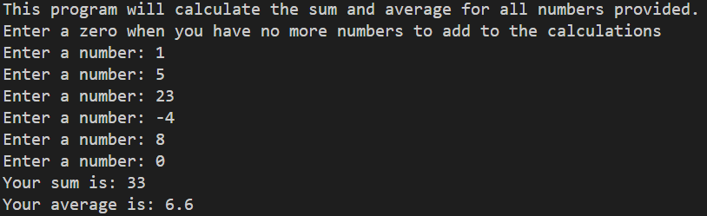

Copy the python code in the section below.

**Python Code**

print("This program will take any numbers you input and calculate their sum and average.")

print("Please enter numbers and type in 0 when you are finished")

number = float(input("Enter a number : "))

numberOfInputs = 0

additionalNumber = 1

*while* additionalNumber != 0:

additionalNumber = float(input("Enter another number : "))

number += additionalNumber

numberOfInputs += 1

print("the sum of all your numbers is: ", number)

print("the average of all your numbers is: ", number/numberOfInputs)

Take a screenshot of an example run of the program and paste it below.

**Example Output**

Run a few more examples with different inputs to make sure it always adds as expected.

**Test Results**

